**KAMPALA PRIVATE TEACHER’S EXAMINATIONS SERIVCES**

***TEL: +25675120144/+256700666538/+256781928207***

**MID TERM I EXAMINATION 2024**

**PRIMARY ONE**

**LITERACY II**

**My name is ____________________________________________**

**I am in _________________________________________________**

**My school is ___________________________________________**

1. **Read these sounds.**

a e s t i

n f m d p

1. **Read these words.**

box nurse pencil mosque bag

egg table church teacher sweeping

tree school Rakai cleaning home

book ball milk woman reading

1. **Read these sentences.**
2. This is a man.
3. That is a stool.
4. It is a spoon.
5. This is a hen.
6. That is a cup.
7. I can see a pencil.
8. That is a school.
9. This is a bed.
10. It is a bird.
11. I can see a broom
12. **Colour.**

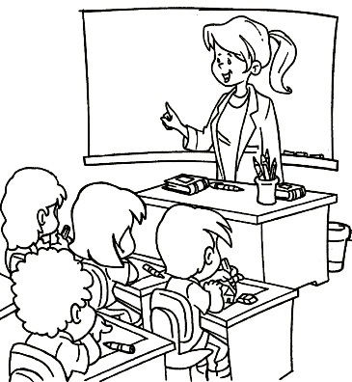

1. **Copy and write.**

**END**